# Brainstorm

**TIP**

You can select a sticky note and hit the pencil [switch to sketch] icon to start drawing!



## Before you collaborate

##### A little bit of preparation goes a long way with this session. Here’s what you need to do to get going.

###### 10 minutes

**1**



## Define your problem statement

##### What problem are you trying to solve? Frame your problem as a How Might We statement. This will be the focus of your brainstorm.

###### 5 minutes

**2**



## Brainstorm

##### Write down any ideas that come to mind that address your problem statement.

###### 10 minutes

**3**



## Group ideas

##### Take turns sharing your ideas while clustering similar or related notes as you go. Once all sticky notes have been grouped, give each cluster a sentence-like label. If a cluster is bigger than six sticky notes, try and see if you and break it up into smaller sub-groups.

###### 20 minutes



**4**



## Prioritize

##### Your team should all be on the same page about what's important moving forward. Place your ideas on this grid to determine which ideas are important and which are feasible.

**20 minutes**



## After you collaborate

You can export the mural as an image or pdf to share with members of your company who might find it helpful.

# & idea prioritization

**PROBLEM**

**How might we [your problem statement]?**

1. **Team gathering**

**TIP**

Add customizable tags to sticky notes to make it easier to find, browse, organize, and categorize important ideas as themes within your mural.

It should be effordable

User friendly

Raspberrypi

Arduino

PERSON 1

PERSON 2 PERSON 3

PERSON 4

Hardware device

Ui interface

cost

**Quick add-ons**



Define who should participate in the session and send an

invite. Share relevant information or pre-work ahead.

Farmers should

Incase of

Bettery must be used to

Interface

more pictorial representation

Final

arduino

Pictorial

As majority of farmers are

If there is nay malfunction full system should be shut down.

The waste

**A Share the mural**

**Share a view link** to the mural with stakeholders to keep

be provided

emergency, the

sustain in the

should be

Eco-

should be

outcome

device can representation

illiterates, Icon Python can can be stored

Use this template in your own

with the user friendly interface.

system should be play an effective role.

power cut situation.

It should be affordable.

Pictorial representation

easy to understand

Friendly

used than words

should be user friendly

be used

is the best than the fonts

representation is the best way

be used

and reused as bio wastes

them in the loop about the outcomes of the session.



The waste

Pictorial representation

Humidity and

Solar panels we should build

motors can be

The intruders

The whole

Every details

Cloud storage

Let's"go with We shouldn't

### brainstorming sessions so your team

Raspberrypi

1. Set the goal

Cost must

should be

tempurature measurement

can be used the device which connected with will reduce the

like birds and system should should be stored

in the database

should be

solar pannels to overcome

make the

**Export the mural**

### can unleash their imagination and start shaping concepts even if you're not sitting in the same room.

Think about the problem you'll be focusing on solving in

the brainstorming session.



1. **Learn how to use the facilitation tools**

Use the Facilitation Superpowers to run a happy and

Every readings should be stored in the cloud

User friendly

affordable.

discarded

perfectly.

Since it is used by farmers,it should have more icon representation than english fonts.

should be

periodically sent to the farmers.

for back up

power

The complete informations should be stored in the cloud for future access

work and stress of the farmers

can be

controlled from anywhere

this device which

rats should be

drive away

Battery back up is must

be water

resistant

for future reference

maintained

effectively

Incase of any malfunction the whole system should be shut down immediately

the powre cut situations

operations

complex

Emergency alert Accessibility

If there is any malfuction full system should be shut down

Incase of high value of humidity and temperature farmers will receive alert messages

It should be only accessed by the owner of the farm

Unknown users shouldn'tb be allowed to access the informations

**B**

Export a copy of the mural as a PNG or PDF to attach to emails, include in slides, or save in your drive.

**10 minutes** to prepare

**1 hour** to collaborate

**2-8 people** recommended

productive session.



[**Open article**](https://support.mural.co/en/articles/2113740-facilitation-superpowers)

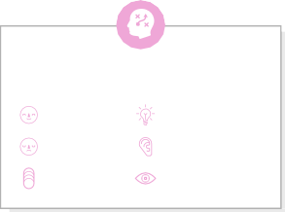

**Key rules of brainstorming**

To run an smooth and productive session

#### Keep moving forward



Strategy blueprint

Define the components of a new idea or strategy.



[Open the template](https://app.mural.co/template/e95f612a-f72a-4772-bc48-545aaa04e0c9/984865a6-0a96-4472-a48d-47639307b3ca)



**Customer experience journey map**

Understand customer needs, motivations, and

Stay in topic. Defer judgment.

Encourage wild ideas. Listen to others.

#### Importance

If each of these

obstacles for an experience.



[**Open the template**](https://app.mural.co/template/b7114010-3a67-4d63-a51d-6f2cedc9633f/c1b465ab-57af-4624-8faf-ebb312edc0eb)



It should be only accessed by the owner of the farm

Incase of value of humidity and temperature farmers will receive alert message.

Unknow user shouldn't be allowed to access the information

Arduino

Go for volume. If possible, be visual.

tasks could get

done without any difficulty or cost, which would have the most positive impact?

Strengths, weaknesses, opportunities & threats

Identify strengths, weaknesses, opportunities, and threats (SWOT) to develop a plan.



Java script

|  |  |
| --- | --- |
|  |  |
|  |  |

[Open the template](https://app.mural.co/template/6a062671-89ee-4b76-9409-2603d8b098be/ca270343-1d54-4952-9d8c-fbc303ffd0f2)



TIP

Participants can use their cursors to point at where sticky notes should go on the grid. The facilitator can confirm the spot by using the laser pointer holding the **H key** on the keyboard.

[Share template feedback](https://muralco.typeform.com/to/CiqaHVat?typeform-source=app.mural.co)

Python



[**Share template feedback**](https://muralco.typeform.com/to/CiqaHVat?typeform-source=app.mural.co)

#### Feasibility

Regardless of their importance, which tasks are more feasible than others? (Cost, time, effort, complexity, etc.)

**Template**

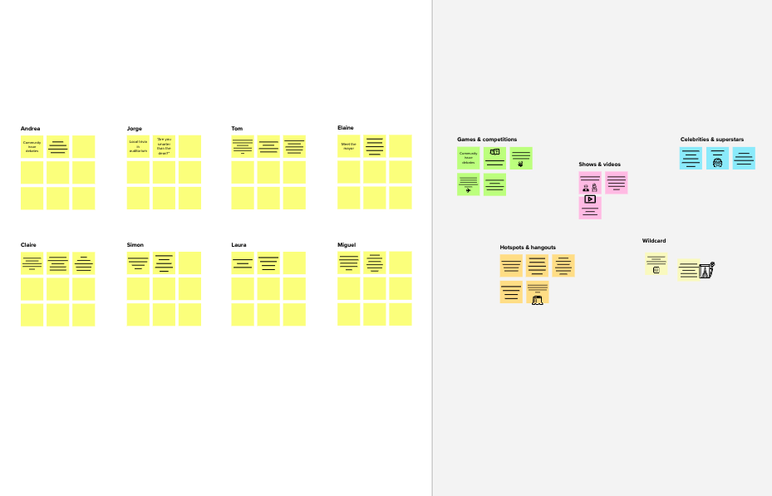

**Need some inspiration?**



See a finished version of this template to kickstart your work.



[**Open example**](https://app.mural.co/template/e5a93b7b-49f2-48c9-afd7-a635d860eba6/93f1b98d-b2d2-4695-8e85-7e9c0d2fd9b9)